**User manual**

**PDF conversion tool**

1. **Introduction**

This manual provides information on how to run the PDF conversion tool. To run the tool via de executable, download and install the tool locally (see section 2.). During conversion to pdf Microsoft Office applications should be closed.

1. **Download and installation**

* Download the PDF conversion tool from the repository (‘PDF_conversion_tool.exe’).
* Double click on the executable to extract the tool to the desired location.

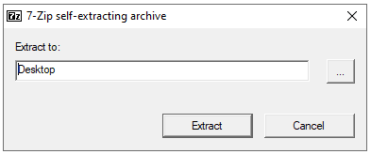

* Open the extracted folder (‘PDF_conversion_tool.exe’).

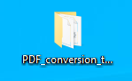

* This folder contains the application file ‘PDF_conversion_tool’.

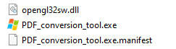

**Do not drag the application file to another location. It is recommended to make a shortcut instead.**

1. **Conversion to PDF**

* Start the tool by double clicking on the application file ‘PDF_conversion_tool’, the shortcut to this file, or by running the file ‘PDF_conversion_tool.py’. Click **OK** to continue.

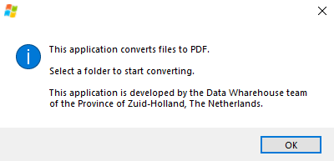

* In the next screen, a choice can be made between selecting files in a folder or a zipped folder. This last option unzips de folder and checks if the file name needs to be adjusted due to a too long path or the existence of files with the same name.

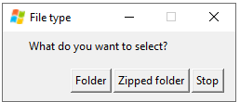

* The tool searches the selected location and counts the number of the different types of files found. Click **Continue** to start converting files to pdf.

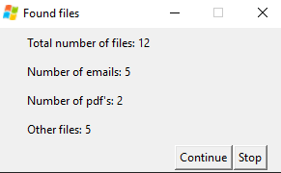

* In the next screen, you can choose whether you want to remove duplicates or not. If ‘Yes’ is chosen, duplicate files will be move to another folder and will not be converted to pdf. To cancel the tool click **Stop**. It may take a while for the process to stop.

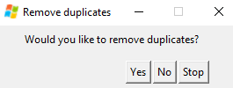

* The progress bar shows the progression the process.

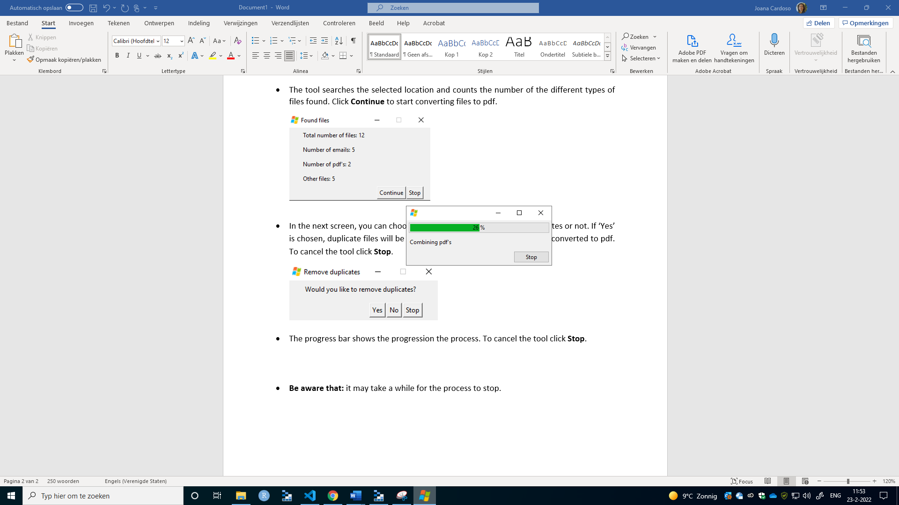

* When the tool is ready with conversion, a final screen shows how many files were converted and where they are located.

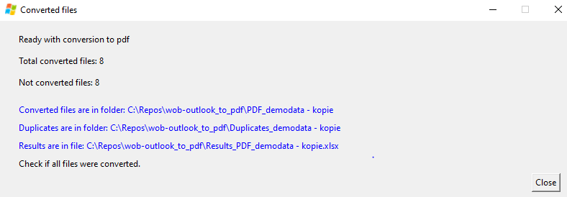

* Click on the blue link to open the folder with the converted files. These are in a folder with the name ‘PDF_<folder name>’. Not converted files are also placed here so that they can be checked.
* In case it was chosen to remove duplicates, these are place in folder ‘Duplicates_<folder name>’.
* An excel file where it is shown what happened with each individual file is created as ‘Results_PDF_<folder name>’.
* To close the tool click **Close**.
* In case a zipped folder is selected as source, an unzipped folder is also created.